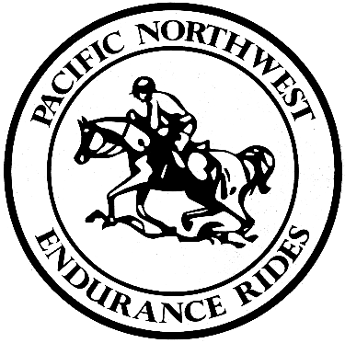
PACIFIC NORTHWEST ENDURANCE RIDES, INC.
CONVENTION 2025

Vendor Registration Form
Please return by Jan. 20, 2025, to klpate88@gmail.com
Contact Information

Company Name: __________________________________________________________

Contact Name: _________ __________________________________________________

Phone: _________________________________________________________________

Mailing Address: __________________________________________________________

Website or email address: __________________________________________________
Space - I need:

One booth Two booths Table only Other

My booth needs an electrical connection: Yes No

Please contact Karen Pate (klpate88@gmail.com) for the costs of special needs or consideration for your booth. We are happy to work with you!

